SEC Form 3
FORM 3 | UNITED STATES SECURITIES AND EXCHANGE COMMISSION  Washington, D.C. 20549  INITIAL STATEMENT OF BENEFICIAL OWNERSHIP OF SECURITIES  Filed pursuant to Section 16(a) of the Securities Exchange Act of 1934  or Section 30(h) of the Investment Company Act of 1940
  OMB APPROVAL
  OMB Number: | 3235-0104
  Estimated average burden
  hours per response: | 0.5
1. Name and Address of Reporting Person*  (Street) | 2. Date of Event Requiring Statement (Month/Day/Year)  08/03/2026 | 3. Issuer Name and Ticker or Trading Symbol  Krispy Kreme, Inc. [ DNUT ]  Foreign Trading Symbol
  Nicholas Suk
  (Last) | (First) | (Middle)
  2116 HAWKINS STREET, SUITE 101
  CHARLOTTE | NC | 28203
  (City) | (State) | (Zip)
 |  | 4. Relationship of Reporting Person(s) to Issuer  (Check all applicable) | 5. If Amendment, Date of Original Filed (Month/Day/Year)
   | Director |  | 10% Owner
   | Officer (give title below) |  | Other (specify below)
  Chief Commercial Officer
6. Individual or Joint/Group Filing (Check Applicable Line)
Form filed by One Reporting Person
Form filed by More than One Reporting Person

Table I - Non-Derivative Securities Beneficially Owned
1. Title of Security (Instr. 4) | 2. Amount of Securities Beneficially Owned (Instr. 4) | 3. Ownership Form: Direct (D) or Indirect (I) (Instr. 5) | 4. Nature of Indirect Beneficial Ownership (Instr. 5)
Common Stock | 89,912(1) | D
Table II - Derivative Securities Beneficially Owned
(e.g., puts, calls, warrants, options, convertible securities)
1. Title of Derivative Security (Instr. 4) | 2. Date Exercisable and Expiration Date (Month/Day/Year) |  | 3. Title and Amount of Securities Underlying Derivative Security (Instr. 4) |  | 4. Conversion or Exercise Price of Derivative Security | 5. Ownership Form: Direct (D) or Indirect (I) (Instr. 5) | 6. Nature of Indirect Beneficial Ownership (Instr. 5)
1. Title of Derivative Security (Instr. 4) | Date Exercisable | Expiration Date | Title | Amount or Number of Shares | 4. Conversion or Exercise Price of Derivative Security | 5. Ownership Form: Direct (D) or Indirect (I) (Instr. 5) | 6. Nature of Indirect Beneficial Ownership (Instr. 5)
Explanation of Responses:
1. Direct DNUT: 27,586 plus 62,326 unvested restricted stock units 62,326 ("RSUs") which will vest as follows: (a) 19,231 RSUs awarded on June 10, 2026 vesting on April 9, 2029; (b) 18,809 RSUs awarded on July 1, 2025 vesting on July 1, 2027; (c) 17,483 RSUs awarded on April 10, 2025 vesting on April 10, 2028; (d) 5,004 RSUs awarded on April 11, 2024 vesting as follows: 3,003 vesting on April 11, 2027, 1,001 on April 11, 2028, and 1,000 on April 11, 2029; (e) 1,316 RSUs awarded on May 9, 2023 vesting as follows: 658 on May 9, 2027 and 658 on May 9, 2028; and (f) 483 RSUs awarded on April 4, 2022 vesting on April 4, 2027.
Remarks:
Exhibit List - Exhibit 24 - Power of Attorney
 | /s/ Christine McDevitt, Attorney-in-fact | 08/03/2026
 | ** Signature of Reporting Person | Date
Reminder: Report on a separate line for each class of securities beneficially owned directly or indirectly.
* If the form is filed by more than one reporting person, see Instruction 5 (b)(v).
** Intentional misstatements or omissions of facts constitute Federal Criminal Violations See 18 U.S.C. 1001 and 15 U.S.C. 78ff(a).
Note: File three copies of this Form, one of which must be manually signed. If space is insufficient, see Instruction 6 for procedure.
Persons who respond to the collection of information contained in this form are not required to respond unless the form displays a currently valid OMB Number.
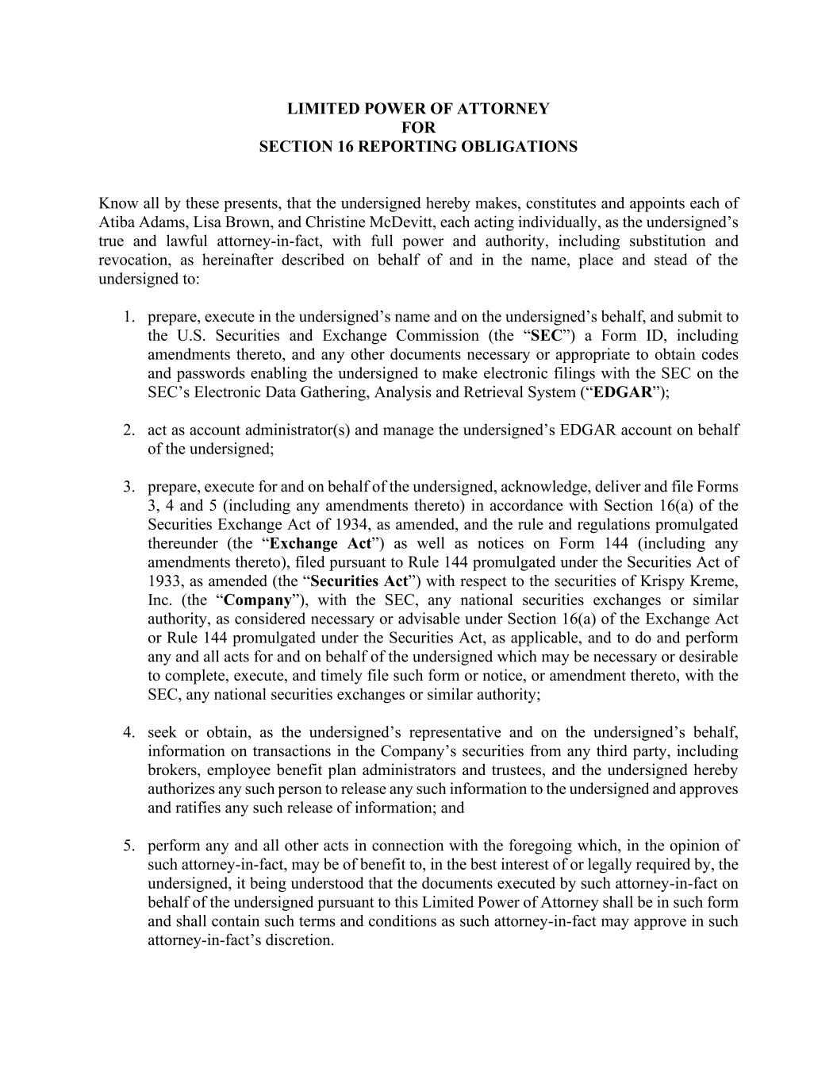
LIMITED POWER OF ATTORNEY FOR SECTION 16 REPORTING OBLIGATIONS Know all by these presents, that the undersigned hereby makes, constitutes and appoints each of Atiba Adams, Lisa Brown, and Christine McDevitt, each acting individually, as the undersigned’s true and lawful attorney-in-fact, with full power and authority, including substitution and revocation, as hereinafter described on behalf of and in the name, place and stead of the undersigned to: 1. prepare, execute in the undersigned’s name and on the undersigned’s behalf, and submit to the U.S. Securities and Exchange Commission (the “SEC”) a Form ID, including amendments thereto, and any other documents necessary or appropriate to obtain codes and passwords enabling the undersigned to make electronic filings with the SEC on the SEC’s Electronic Data Gathering, Analysis and Retrieval System (“EDGAR”); 2. act as account administrator(s) and manage the undersigned’s EDGAR account on behalf of the undersigned; 3. prepare, execute for and on behalf of the undersigned, acknowledge, deliver and file Forms 3, 4 and 5 (including any amendments thereto) in accordance with Section 16(a) of the Securities Exchange Act of 1934, as amended, and the rule and regulations promulgated thereunder (the “Exchange Act”) as well as notices on Form 144 (including any amendments thereto), filed pursuant to Rule 144 promulgated under the Securities Act of 1933, as amended (the “Securities Act”) with respect to the securities of Krispy Kreme, Inc. (the “Company”), with the SEC, any national securities exchanges or similar authority, as considered necessary or advisable under Section 16(a) of the Exchange Act or Rule 144 promulgated under the Securities Act, as applicable, and to do and perform any and all acts for and on behalf of the undersigned which may be necessary or desirable to complete, execute, and timely file such form or notice, or amendment thereto, with the SEC, any national securities exchanges or similar authority; 4. seek or obtain, as the undersigned’s representative and on the undersigned’s behalf, information on transactions in the Company’s securities from any third party, including brokers, employee benefit plan administrators and trustees, and the undersigned hereby authorizes any such person to release any such information to the undersigned and approves and ratifies any such release of information; and 5. perform any and all other acts in connection with the foregoing which, in the opinion of such attorney-in-fact, may be of benefit to, in the best interest of or legally required by, the undersigned, it being understood that the documents executed by such attorney-in-fact on behalf of the undersigned pursuant to this Limited Power of Attorney shall be in such form and shall contain such terms and conditions as such attorney-in-fact may approve in such attorney-in-fact’s discretion.

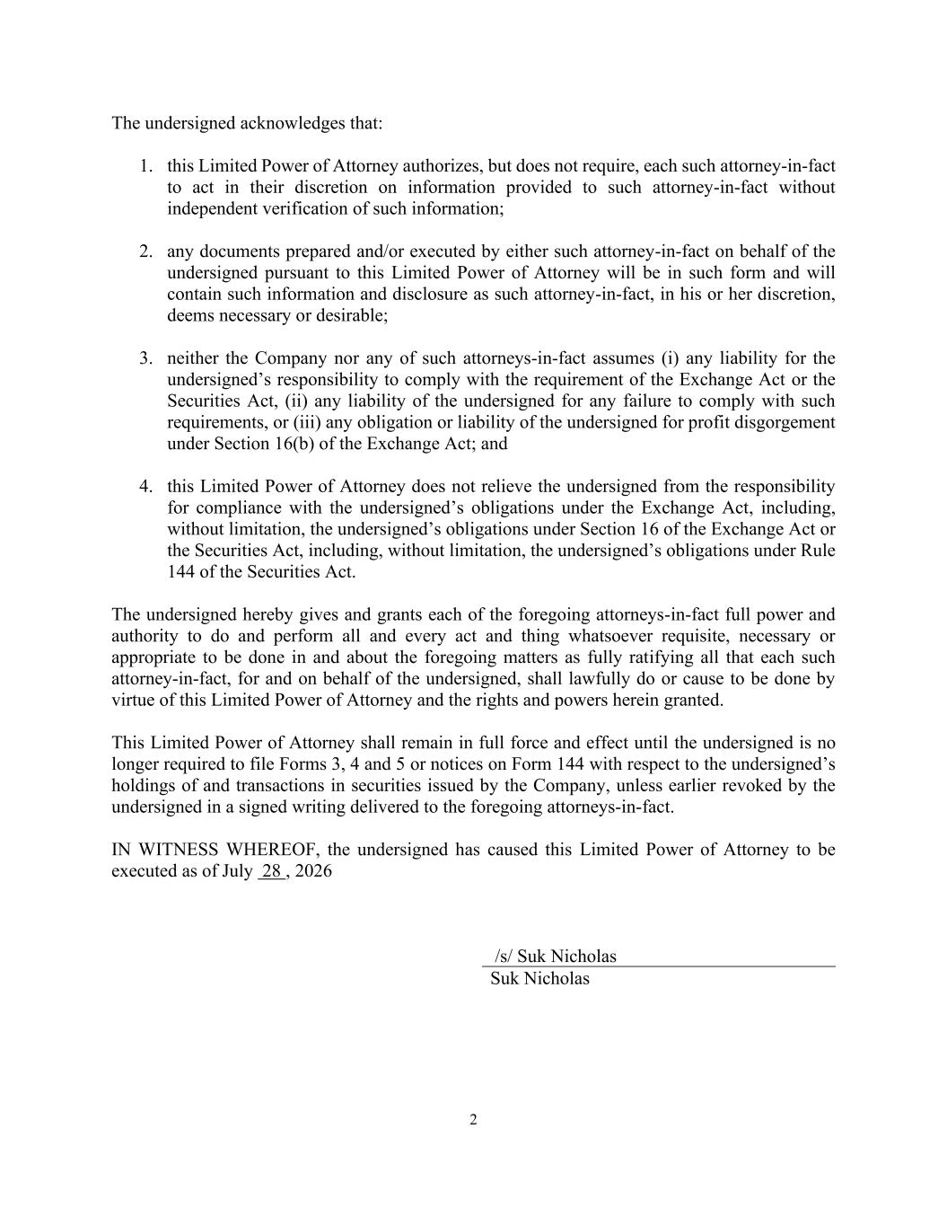
2 The undersigned acknowledges that: 1. this Limited Power of Attorney authorizes, but does not require, each such attorney-in-fact to act in their discretion on information provided to such attorney-in-fact without independent verification of such information; 2. any documents prepared and/or executed by either such attorney-in-fact on behalf of the undersigned pursuant to this Limited Power of Attorney will be in such form and will contain such information and disclosure as such attorney-in-fact, in his or her discretion, deems necessary or desirable; 3. neither the Company nor any of such attorneys-in-fact assumes (i) any liability for the undersigned’s responsibility to comply with the requirement of the Exchange Act or the Securities Act, (ii) any liability of the undersigned for any failure to comply with such requirements, or (iii) any obligation or liability of the undersigned for profit disgorgement under Section 16(b) of the Exchange Act; and 4. this Limited Power of Attorney does not relieve the undersigned from the responsibility for compliance with the undersigned’s obligations under the Exchange Act, including, without limitation, the undersigned’s obligations under Section 16 of the Exchange Act or the Securities Act, including, without limitation, the undersigned’s obligations under Rule 144 of the Securities Act. The undersigned hereby gives and grants each of the foregoing attorneys-in-fact full power and authority to do and perform all and every act and thing whatsoever requisite, necessary or appropriate to be done in and about the foregoing matters as fully ratifying all that each such attorney-in-fact, for and on behalf of the undersigned, shall lawfully do or cause to be done by virtue of this Limited Power of Attorney and the rights and powers herein granted. This Limited Power of Attorney shall remain in full force and effect until the undersigned is no longer required to file Forms 3, 4 and 5 or notices on Form 144 with respect to the undersigned’s holdings of and transactions in securities issued by the Company, unless earlier revoked by the undersigned in a signed writing delivered to the foregoing attorneys-in-fact. IN WITNESS WHEREOF, the undersigned has caused this Limited Power of Attorney to be executed as of July 28 , 2026 /s/ Suk Nicholas Suk Nicholas

